Order Data analysis (Joins)

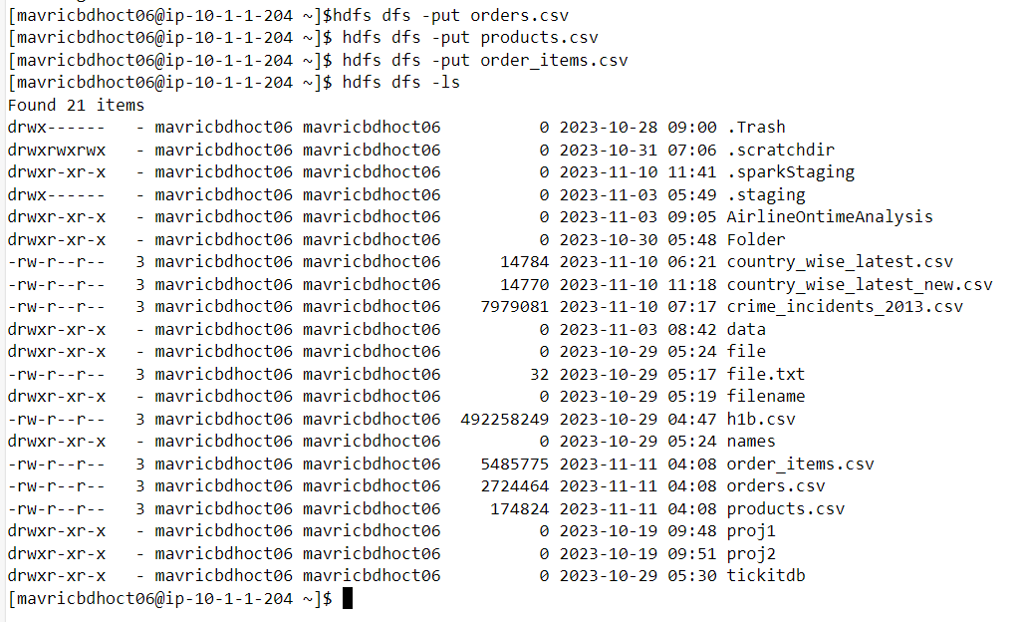

1. Problem Statement: What is the daily product revenue for CLOSED or COMPLETE orders?

1. Load the required data in to DF like categories, customer,departments,order_items,orders and products

orderitemsDF=spark.read.option("header",True).option("inferschema",True).csv("order_items.csv")

orderitemsDF.createOrReplaceTempView("orderitems")

orderitemsDF.printSchema()

ordersDF=spark.read.option("header",True).option("inferschema",True).csv("orders.csv")

ordersDF.createOrReplaceTempView("orders")

ordersDF.printSchema()

productsDF=spark.read.option("header",True).option("inferschema",True).csv("products.csv")

productsDF.createOrReplaceTempView("products")

productsDF.printSchema()

1. Get the count for each order status

4. Filter only COMPLETE or CLOSED orders

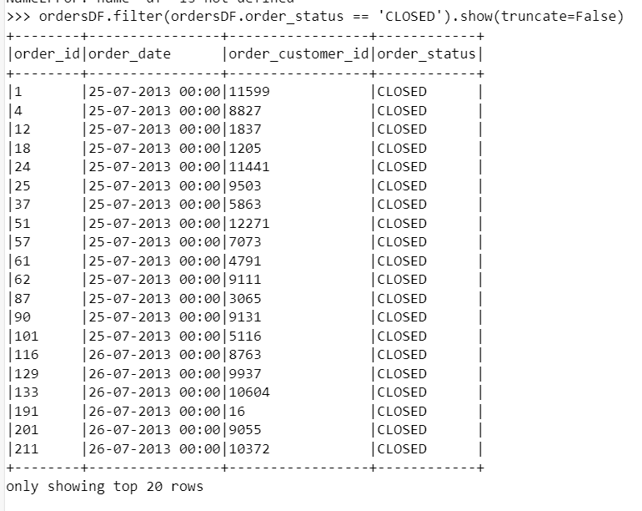

5. Join the products , order_items and orders tables and calculate daily product revenue

6. Write the data in to the table Daily product revenue in Hive



